Time Intelligence
Time Intelligence functions in DAX let you calculate values over different periods of time — this year vs last year, this month vs previous month, year-to-date, rolling periods, etc.
They are the tools you use when you want answers like:
- “How much revenue did we make so far this year?”
- “How does this month compare to last month?”
- “What was revenue in the same period last year?”

Important Time Intelligence Functions
1. Period-to-Date Functions
Function | What it does
TOTALYTD | Year-to-Date total
TOTALQTD | Quarter-to-Date total
TOTALMTD | Month-to-Date total
YTD means Year-to-Date.
It calculates the total from the 1st January of the current year up to the selected date (or the latest date in your data).
Simple Example
Imagine today is 15th March 2018:
Period | What YTD covers
YTD | 1 Jan 2018 → 15 Mar 2018
Full Year | 1 Jan 2018 → 31 Dec 2018
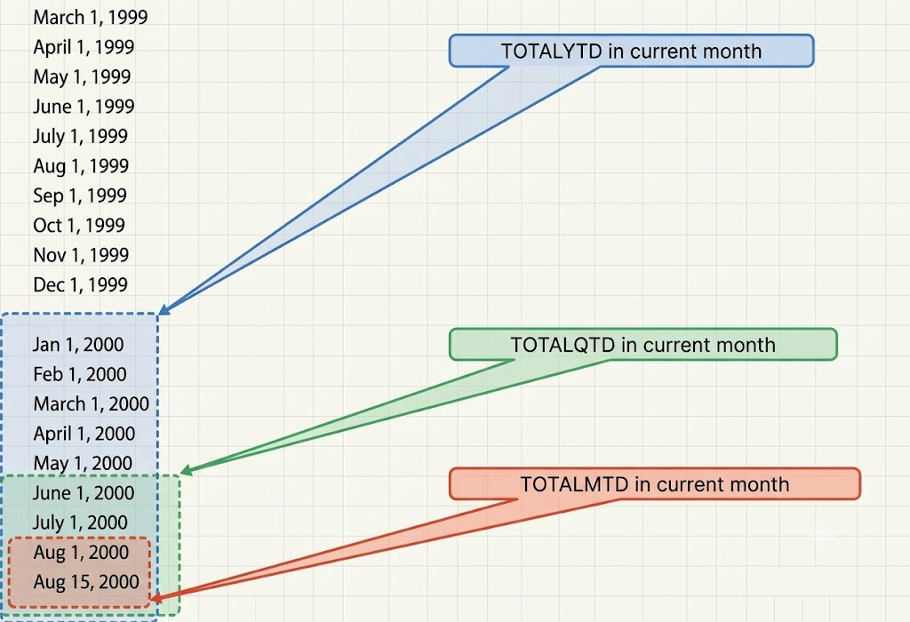

2. Previous / Parallel Period Functions
Function | What it does
SAMEPERIODLASTYEAR | Same period one year ago
PREVIOUSYEAR | Previous year
PREVIOUSQUARTER | Previous quarter
PREVIOUSMONTH | Previous month
PARALLELPERIOD | Shifts by full periods (year/quarter/month)
DATEADD | Shifts dates by any number of days/months/quarters/years

1. SAMEPERIODLASTYEAR
What it does:
Returns the exact same period (same days) but one year earlier.
Syntax:
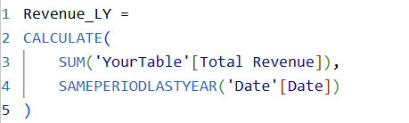
If you are looking at March 2018, it returns March 2017.
If you are looking at 15-Mar-2018, it returns 15-Mar-2017.
Best for: Year-over-Year comparison of the exact same period.

2. PREVIOUSYEAR
What it does:
Returns the entire previous year.
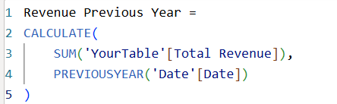
If you are in 2018, it returns the full year 2017.
Best for: Comparing full years.

DATEADD and PARALLELPERIOD are both DAX time intelligence functions in Power BI. They shift a set of dates forward or backward and are typically used inside CALCULATE to compare values across periods. They look similar but behave differently, especially regarding the length and granularity of the period they return.

Aspect | DATEADD | PARALLELPERIOD
Behavior with partial periods | Keeps partial periods (e.g., June 10–21 shifted one month → July 10–21) | Expands to the full parallel period (e.g., June 10–21 shifted one month → entire July 1–31)

3. Rolling / Moving Window Functions
Function | What it does
DATESINPERIOD | Creates a rolling period (last N days/months)
DATESBETWEEN | Returns dates between two specific dates
4. Start & End of Period Functions
Function | What it does
STARTOFYEAR / ENDOFYEAR | First / last day of the year
STARTOFQUARTER / ENDOFQUARTER | First / last day of the quarter
STARTOFMONTH / ENDOFMONTH | First / last day of the month

Group 1: Period-to-Date (YTD, QTD, MTD)
1. TOTALYTD
The finance team wants to see revenue accumulated from the beginning of the year until the selected date.
Write a measure using TOTALYTD that calculates Year-to-Date Total Revenue.
2. TOTALQTD
Management wants to track quarterly progress.
Create a measure using TOTALQTD that shows Quarter-to-Date Total Revenue.
3. TOTALMTD
Sales managers need daily tracking within the current month.
Create a measure using TOTALMTD that calculates Month-to-Date Total Revenue.
Group 2: Comparing with Previous Periods
4. SAMEPERIODLASTYEAR
Leadership wants to compare this year’s performance with the same period last year.
Write a measure using SAMEPERIODLASTYEAR that returns Total Revenue for the same period last year.
5. PREVIOUSMONTH
The sales team wants to see last month’s revenue.
Create a measure using PREVIOUSMONTH that shows Total Revenue of the previous month.
6. PREVIOUSQUARTER
Create a measure using PREVIOUSQUARTER that returns Total Revenue of the previous quarter.
7. DATEADD
Create a measure using DATEADD that shows Total Revenue from one year ago.
8. PARALLELPERIOD
Create a measure using PARALLELPERIOD that returns Total Revenue for the same period last year (full periods).

Group 3: Rolling Windows
9. DATESINPERIOD – Last 30 Days
Marketing wants to see recent performance.
Write a measure using DATESINPERIOD that calculates Total Revenue for the last 30 days.
10. DATESINPERIOD – Last 12 Months
Create a measure that calculates the Moving Annual Total (last 12 months revenue) using DATESINPERIOD.

Group 4: Growth Calculations (Combining Functions)
11. YoY Growth %
What is year-over-year growth (YoY meaning)?
Year-over-year (YOY) is the comparison of one period with the same period from the previous year(s). YOY growth compares how much you’ve grown in the recent period compared to the past period(s). The period is typically a month or quarter (e.g., fourth quarter of 2020 compared to fourth quarter of 2019).
The YOY growth rate is a percentage change. How much growth have you had during this year’s time period compared to last year’s? Did you have an increase or decrease in the performance area you’re analyzing?
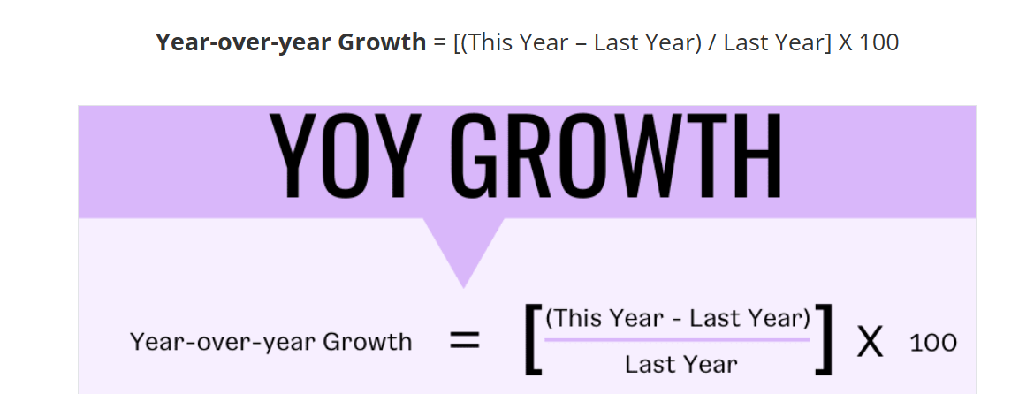

Create a measure that calculates Year-over-Year Growth % using SAMEPERIODLASTYEAR.
12. MoM Growth %
Create a measure that calculates Month-over-Month Growth % using DATEADD or PREVIOUSMONTH.
13. QoQ Growth %
Create a measure that calculates Quarter-over-Quarter Growth % using PARALLELPERIOD or DATEADD.

Group 5: Understanding the Difference
14. SAMEPERIODLASTYEAR vs DATEADD vs PARALLELPERIOD
Create three measures that all try to get “Revenue Last Year”:
- One using SAMEPERIODLASTYEAR
- One using DATEADD(..., -1, YEAR)
- One using PARALLELPERIOD(..., -1, YEAR)
Then explain (or observe) the difference between them.

